REPUBLIC OF RWANDA
UNIVERSITY OF LAY ADVENTISTS OF KIGALI (UNILAK)

KIGALI CAMPUS
P.O.BOX 6392 KIGALI, Phone: +250731743430/+250731743431
Email: info@unilak.ac.rw; Website: www.unilak.ac.rw
FACULTY OF COMPUTING AND INFORMATION SCIENCES
DEPARTMENT OF SOFTWARE ENGINEERING
ACADEMIC YEAR: 2025-2026
E-Ticket: A Digital Solution for Efficient Bus ticket booking Optimization
CASE STUDY: Rural Areas

A final project submitted to the faculty of Computing and Information Sciences in
Partial fulfilment of academic requirements for the award of a Bachelor’s Degree of
Science in Software Engineering.
Submitted by:
HABUMUGISHA Eric
Student ID: 19469/2022
Under the guidance of:
Mrs. NIYOGAKIZA Denyse
Kigali, February, 2024

DECLARATION

I, Eric HABUMUGISHA, hereby declare that the project report entitled " E-Ticket: A Digital Solution for Efficient Bus ticket booking Optimization", submitted in partial fulfilment of the requirements for the award of the degree of Bachelor of Science in Software Engineering, is a record of original work carried out by myself under the guidance and supervision of Denyse NIYOGAKIZA
I further declare that this work has not been submitted, either in part or in full, for the award of any other degree or diploma at this institution or any other university.

Eric HABUMUGISHA
Kigali:
Date: ____ / _____ / 2025
Signature: __________________________


FACULTY OF COMPUTING & INFORMATION SCIENCE, DEPARTMENT SOFTWARE ENGINEERING
B.P. 6392 KIGALI: Tel: +25055107311/55104697
E-mail: contact@unilak.ac.rw; Web site: www.unilak.ac.rw

BONAFIDE CERTIFICATE
This is to certify that the project report entitled " E-Ticket: A Digital Solution for Efficient Bus ticket booking Optimization ", submitted by HABUMUGISHA Eric 19469/2022 to the University of Lay Adventists of Kigali, in partial fulfilment of the requirements for the award of the Bachelor’s Degree in Information Systems and Management, is a record of bonafide work carried out by the student under my guidance.

SUPERVISOR
Mrs.Denyse NIYOGAKIZA
Date: …… /…… /2025

DEAN OF FACULTY
Dr. Enam Nyesheja Muhire, PhD
Date: …… /…… /2025

DEDICATION

To the almighty God
To my parents
To my siblings
To my supervisor
To Cis lecturers
To my friends and relatives
Your love, believing in me, patience, kindness and support helped me through my journey of Batchelor’s education may the might God bless you abundantly.

ACKNOWLEDGMENT
I express my deepest gratitude to God Almighty, whose guidance, strength, and unwavering support have been my foundation throughout this journey.
My sincere thanks go to my supervisor, Mrs, Denyse NIYOGAKIZA, for her invaluable mentorship, insightful recommendations, and unwavering support, which played a crucial role in shaping the success of this project. Her belief in this work from its inception has been truly inspiring, and I am honoured to have benefited from her expertise.
I extend my heartfelt appreciation to my friends, colleagues, and mastermind groups, whose critical reviews, thoughtful feedback, and encouragement greatly contributed to the refinement and improvement of this work. Your insights have been invaluable in shaping the development of this system.
A special note of gratitude goes to my university IT lecturers, whose mentorship, technical expertise, and guidance have been instrumental in realizing this project. Their support throughout my academic journey has been a cornerstone of my learning and professional growth.
Finally, I wish to express my sincere appreciation to everyone who believed in my idea, offered support in any form, and provided constructive criticism. Your contributions—whether big or small—have made a meaningful impact on the completion of this work.

Eric HABUMUGISHA

TABLE OF CONTENT
Table of Contents
DECLARATION ii
BONAFIDE CERTIFICATE iii
DEDICATION iv
ACKNOWLEDGMENT v
TABLE OF CONTENT vi
LIST OF FIGURES viii
LIST OF TABLES ix
LIST OF ABBREVIATIONS AND ACRONYMS x
ABSTRACT xi
CHAPTER ONE: GENERAL INTRODUCTION 1
1.1 Introduction 1
1.2 Background of the Study 1
1.3 Problem Statement 2
1.4 Project Objectives 2
1.4.2 Specific Objectives: 3
1.5 Motivation 3
1.6 Challenges 3
1.7 Methodology and Techniques 4
1.8 Scope of the Research 4
1.9 Statement of Assumptions 4
1.10 Expected Results 5
1.11 Organization of the Report 5
Chapter Two: LITERATURE REVIEW 6
2.1 Introduction 6
2.4. Application Program Concept 11
2.5. Comparative Study of Similar Works 12
2.6. Gap Analysis 12
2.7. Research Contribution 12
CHAPTER THREE: ANALYSIS OF EXISTING SYSTEM 14
3.1 Introduction 14
3.2 Description of Existing Systems 14
3.2.1 Manual Ticketing System 14
3.2.2 Smart/Digital ticketing System 20
CHAPTER FOUR: ANALYSIS AND DESIGN OF THE NEW SYSTEM 25
4.1 Introduction 25
4.2 Analysis and Design Methodology 26
4.2.1 System 26
4.2.2 System Life Cycle 26
4.3 Structured System Analysis and Design Method (SSADM) 27
4.4 Functional Diagram 28
4.5 Data Flow Diagram (DFD) for E-Ticket 29
4.5.1 Components of the E-Ticket DFD 29
4.6 Data Flow Diagram Symbols 30
1. External Entity 30
2. Process 31
3. Data Flow 31
4. Data Store 31
4.7 Context Diagram 32
4.8 DFD Level 1 for E-Ticket 33
4.9 DFD Level 2 for E-Ticket 34
4.10 Entity Relationship Diagram (ERD) 36
4.11 Logical Data Model (LMD) 39
4.12 Data Dictionary for E-Ticket 40
4.13 Physical Data Model (PDM) 42
CHAPTER FIVE: IMPLEMENTATION OF THE NEW SYSTEM 43
5.1. Introduction 43
5.2. System Interface 44
5.3 Screenshots 44
Bus Schedule Management Page 46
CHAPTER SIX: CONCLUSION AND RECOMMENDATION 50
6.1. Introduction 50
6.2. Problem Encountered 50
6.3. Lessons Learnt 51
6.4. Critical Assessment of the Project 51
6.5 Generate Reports: 52
6.6 Recommendation 52
2.8 References 53

LIST OF FIGURES

Figure 2:Functional Diagram 34
Figure 3:Context Diagram 39
Figure 4: DFD Level 1. 40
Figure 5: Sub-Processes of User Registration and Authentication 40
Figure 6:Sub-Processes of Ticket Booking Management 41
Figure 7: Sub-Processes of Payment Processing 41
Figure 8:Sub-Processes of Report Processing 41
Figure 9:ERD for E-Ticket 44
Figure 10: Physical data model 48

LIST OF TABLES

Table 1:bus table 47
Table 2: Ticket table 47
Table 3: transaction table 47
Table 4: Payment table 48
Table 5: schedule table 48

LIST OF ABBREVIATIONS AND ACRONYMS
• DBMS – Database Management System
• SQL – Structured Query Language
• MVC – Model-View-Controller
• SSADM – Structured Systems Analysis and Design Methodology
• PHP – Hypertext Preprocessor
• HTML – Hypertext Markup Language
• CSS – Cascading Style Sheets
• MySQL – My Structured Query Language
• UI – User Interface
• UX – User Experience
• API – Application Programming Interface
• CRUD – Create, Read, Update, Delete
• HTTPS – Hypertext Transfer Protocol Secure
• OTP – One-Time Password

ABSTRACT
The eTicket Bus Pass Management System is a digital solution designed to modernize and automate bus pass issuance and management in Kigali's public transportation network. Traditional ticketing methods in horizon express often lead to long queues, lost tickets, and inefficiencies in fare collection, affecting both passengers and administrators. This project addresses these challenges by introducing a web-based system that ensures convenience, accuracy, and seamless service delivery.
The system development follows the Structured Systems Analysis and Design Methodology (SSADM) to ensure a well-structured and efficient design. PHP (Laravel) serves as the core development framework, while MySQL handles database management. The system follows the Model-View-Controller (MVC) architecture, ensuring scalability, maintainability, and efficient data organization.
Key features include online ticket booking, passenger registration, payment tracking, and real-time reporting. The system also provides role-based authentication, granting passengers access to ticket management while allowing administrators to monitor transactions and generate insights for operational improvements.
The implementation of eTicket significantly enhances the efficiency of bus pass management, reducing manual workload, eliminating errors, and ensuring secure transactions. Findings from this study indicate that automation improves data accuracy, service accessibility, and decision-making in public transport operations. By embracing digital solutions, eTicket lays the foundation for a smarter, more efficient urban transit system.

CHAPTER ONE: GENERAL INTRODUCTION

1.1 Introduction
In the contemporary urban setting, efficient public transportation systems are crucial for economic development and the daily mobility of citizens. In Rural areas, the current method of accessing public buses is predominantly manual. Commuters often rely on visiting bus parks or waiting at designated stops without knowledge of the exact bus arrival times. This lack of real-time information results in uncertainty, long waiting periods, and inconvenience. To address these challenges, a Bus Pass Management web Application is proposed. The application aims to streamline the process of issuing and renewing bus passes while providing booking information, thereby enhancing the user experience and operational efficiency of bus services.

This research proposal aims to develop a web-based E-Ticket System that will simplify the process of issuing and renewing bus passes for public transportation in Rural areas. The system will provide a more efficient, convenient, and user-friendly approach to managing bus passes, helping both users and bus operators. In Rural Areas, many Commuters /users/ passengers currently face challenges due to the lack of real-time information about bus schedules. The proposed system seeks to address this by offering users access to bus pass management features such as online pass renewal, bus booking, and real-time updates, which will make commuting more predictable and less stressful.

1.2 Background of the Study
Public transportation in rural areas faces several challenges, one of which is the unpredictability of bus arrival times. Passengers often wait for buses without knowing when the next bus will arrive, leading to time inefficiencies. Commuters rely on rough estimates or inquire about the buses at the bus stations, which does not always guarantee accurate information. Additionally, the manual process of issuing and renewing bus passes is often time-consuming and inconvenient. These challenges highlight the need for an automated system that will offer accurate and real-time information to passengers, improving the overall public transport experience. The development of a web-based bus E-Ticket can provide an effective solution by integrating booking and easy access to bus pass services.
This study focuses on rural areas as a case study to explore how technology can address challenges in the current public transportation system. By leveraging web technology, this project seeks to integrate digital solutions to improve the reliability and accessibility of public transport services .

1.3 Problem Statement
The current public transportation system in rural areas faces significant challenges, particularly in the process of bus pass management and real-time access to bus schedules. Commuters often:
• Wait for buses without knowing their exact arrival times.
• Face delays due to inadequate information on bus schedules.
• Spend time and resources traveling to physical locations for bus pass issuance or renewal.
These challenges lead to inefficiencies, time wastage, and commuter dissatisfaction. There is a critical need for a web-based system that simplifies bus pass management and provides real-time updates on bus schedules to bridge these gaps.

1.4 Project Objectives
1.4.1 General Objective:
To design and develop a web-based Bus E-Ticket that will simplify the issuance, renewal,and management of bus passes in rural areas, while providing real-time information on bus schedules before and after arrivals to commuters .

1.4.2 Specific Objectives:
- To create a user-friendly interface for issuing and renewing bus passes online.
- To integrate payment systems for online pass renewals.

1.5 Motivation
1.5.1 Personal Motivation:
Having experienced the challenges of public transport in Rural areas first-hand, including the uncertainty of bus arrival times, I am motivated to contribute to a solution that will enhance the efficiency of the city's public transportation system. The development of a Bus E-Ticket that simplifies access to transportation and offers real-time information would be beneficial to both commuters and bus operators.

1.5.2. Research Motivation:
The challenges faced by Rural areas commuters present an opportunity to explore innovative solutions for improving public transport. Developing a web-based system to address these issues will not only benefit the public but also contribute to the broader field of transportation technology. Through this research, I hope to highlight the importance of technology in solving real-world problems in urban transportation .

1.6 Challenges
The primary challenges that may arise during the development of this system include ensuring the accuracy of booking data, integrating the system with existing transportation infrastructure, and gaining user adoption. Additionally, the development of a secure payment gateway for bus pass renewals may involve technical and regulatory hurdles. These challenges will be addressed through rigorous testing, collaboration with bus operators, and exploring existing transportation technology solutions.

1.7 Methodology and Techniques
The research will employ a software development methodology, utilizing the agile framework to ensure flexibility and adaptability during the system’s development process. The Web development environment will be used for building the application, integrating features such as online pass management, real-time bus information, and payment systems. Additionally, data collection methods such as user surveys and feedback will be used to evaluate the effectiveness and usability of the system .

1.8 Scope of the Research
This research will focus on the development of a web-based Bus E-Ticket Specifically for Rural areas. It will cover the design and implementation of the web-based application, including features for bus pass issuance, renewal, and booking. The system will not be limited to users of public buses in Kigali, with future expansion potential to include other modes of transportation in the city. The research will also explore the integration of payment systems and the collection of data for improving system performance.
- In few words the research will cover (Focus on commuter needs such as bus pass issuance, renewal.
- Address operational challenges faced by bus operators in managing bus passes.
- Exclude private transportation systems and intercity bus service .

1.9 Statement of Assumptions
It is assumed that the current public transportation infrastructure in Rural areas can be integrated with the proposed system to provide real-time booking of buses. Additionally, it is assumed that the target users are familiar with smartphones and basic web-based applications. It is also assumed that sufficient funding and resources will be available to develop and test the system. In shortly we assume that:
- Rural area’s public transportation operators are willing to collaborate by providing necessary data, such as bus schedules and operational routes.
- The majority of commuters in rural areas own or have access to smartphones with Web operating systems.
- There is sufficient internet connectivity to support the application’s functionalities.
- Stakeholders are open to adopting a digital solution to address existing transportation challenges.

1.10 Expected Results
The successful implementation of this project is expected to yield the following results:
- A functional Web application that simplifies the process of issuing and
Renewing bus passes.
- Improved commuter satisfaction due to reduced waiting times and
Enhanced convenience.
- Increased operational efficiency for bus service providers in rural areas.
- A scalable solution that can be adapted to other cities with similar challenges.

1.11 Organization of the Report
The report will be organized into five main chapters:
- Chapter One: General Introduction – This chapter introduces the research topic, including the background, problem statement, objectives, and motivation.
- Chapter Two: Literature Review – This chapter reviews existing research and systems related to bus pass management and public transportation in urban areas.
- Chapter Three: System Design and Methodology – This chapter outlines the system architecture, design, and methodology used in the development of the E-Ticket.
- Chapter Four: Implementation and Results – This chapter details the implementation process, including the development of the web application and the results obtained from testing.
- Chapter Five: Testing and Evaluation – Discusses the testing processes and evaluates the system’s performance based on predefined metrics.
- Chapter six: Conclusion and Recommendations – This chapter summarizes the findings of the research, provides conclusions, and suggests future improvements for the system.
This structure will ensure that the research is comprehensive and well-organized, with each section building on the previous one to provide a clear understanding of the project's development and impact.

Chapter Two: LITERATURE REVIEW

2.1 Introduction
Technology has played a significant role in reshaping industries, and public transportation is no exception. The integration of digital solutions into transportation systems has improved efficiency, reduced costs, and enhanced user experiences. The traditional paper-based ticketing system has been replaced by electronic ticketing (E-Ticket) systems, allowing passengers to book, manage, and validate their travel digitally.
This chapter presents a review of existing literature related to the development of a web-based E-Ticket system for public transportation. It explores the evolution of ticketing systems, relevant technologies, and database concepts while identifying the gaps in previous research. Additionally, this review examines the impact of digital payment solutions, real-time database systems, and backend technologies such as MySQL, PHP ( Laravel) in developing robust and secure E-Ticketing systems. The findings from this chapter provide a foundation for understanding the current landscape of E-Ticketing and the technological advancements that contribute to its implementation.

2.2 Definition of Key Terms
Understanding the key terms related to the system is essential for grasping the fundamental concepts behind its design and functionality. Below are the detailed definitions of the key terms:
2.2.1 E-Ticket (Electronic Ticket)
An E-Ticket is a digital alternative to traditional paper tickets used for booking and accessing services such as transportation, entertainment, and events. It is generated electronically and stored in a database, allowing users to present a QR code, barcode, or digital confirmation instead of a physical ticket. In the context of an E-Ticket, e-tickets enable passengers to book and validate their travel without requiring printed tickets, improving efficiency and reducing paper waste.
2.2.2 Payment Systems for Online Pass Renewals
Payment systems for online pass renewals refer to the digital financial transaction mechanisms integrated into applications to facilitate secure and convenient payments for issuing and renewing passes. These systems use technologies such as mobile money, credit/debit card payments, online banking, and digital wallets (e.g., PayPal, Stripe) to enable users to make transactions remotely. In E-Ticket, this feature allows passengers to renew their travel passes seamlessly without visiting physical offices .

2.2.3 Database
A Database is a database system designed to process and update data instantly, ensuring that users always have access to the most recent information. Unlike traditional databases that update data at scheduled intervals, real-time databases synchronize changes as soon as they occur. This is particularly useful in applications that require live updates, such as transportation systems, stock markets, and messaging platforms. In E-Ticket, a database ensures that booking confirmations, seat availability, and payment statuses are updated without delays.

2.2.4 MySQL
MySQL is a widely used open-source Relational Database Management System (RDBMS) that enables efficient storage, retrieval, and management of structured data. It supports Structured Query Language (SQL) and integrates seamlessly with various backend technologies, making it a preferred choice for web applications. MySQL is known for its scalability, security, and reliability, making it suitable for small and large-scale applications. In E-Ticket, MySQL can store and manage passenger details, ticket bookings, payment records, and travel history efficiently.

2.2.5 PHP
PHP (Hypertext Preprocessor) is a popular open-source server-side scripting language primarily used for web development. It enables the creation of dynamic and interactive web pages by processing requests on the server and generating HTML output for users. PHP can interact with databases, handle authentication, and process form data, making it an essential technology for web-based applications. In E-Ticket, PHP is used to handle backend operations such as user authentication, ticket generation, and database interactions.

2.2.6 Laravel
Laravel is a robust PHP framework designed to simplify web application development through elegant syntax and built-in features. It provides a structured approach to coding, making it easier to manage complex applications. Laravel offers powerful tools such as authentication, routing, database migrations, and ORM (Eloquent) for interacting with databases efficiently. Additionally, it enhances security through built-in protection mechanisms against common web vulnerabilities. In an E-Ticket, Laravel ensures smooth backend operations, including managing users, processing payments, and maintaining a secure database structure.
By understanding these key terms, one can better comprehend the structure, functionality, and technologies used in the E-Ticket, ensuring effective development and implementation.

2.3 Database Concept
A database is a structured collection of data that enables efficient storage, retrieval, and management of information. The database concept encompasses fundamental principles that guide the organization, structuring, and handling of data in a systematic manner. Below are key sub-concepts that form the backbone of database systems:

2.3.1 Data
Data refers to raw facts, figures, or symbols that, when processed, become meaningful information. Examples of data include numbers, names, dates, and measurements. Data can exist in various formats, such as text, images, audio, or video.

2.3.2 Database
A database is an organized collection of structured data stored electronically. It allows users to store, retrieve, update, and manage data efficiently. Databases can be classified into different types, such as relational, hierarchical, object-oriented, and NoSQL databases.

2.3.3 Entity
An entity represents an object, person, place, or concept that holds specific characteristics and is stored in a database. For example, in a university database, Student and Course can be considered entities, each having attributes such as Student Name and Course Code.
2.3.4 Table
A table is the primary structure used to organize data in a relational database. It consists of rows (records) and columns (fields or attributes). Each row represents a single record, while each column defines a specific type of data stored. For example, a Students table may have columns for Student ID, Name, Age, and Course.

2.3.5 Primary Key
A primary key is a unique identifier for each record in a database table. It ensures that no two records have the same value in the primary key field, preventing duplication. For example, in a Students table, the Student ID can serve as the primary key since each student has a unique ID.
2.3.6 Foreign Key
A foreign key is a field in one table that creates a relationship with another table. It references the primary key of another table, ensuring data consistency. For example, if there is a Courses table with Course ID as the primary key, a Students table may have Course ID as a foreign key to link students to their courses.

2.3.7 Data Modelling
Data modelling is the process of defining and analysing data requirements to design a database structure. It involves creating a conceptual representation of data relationships and includes models such as the Entity-Relationship Diagram (ERD). Data modelling helps in defining how data is stored, accessed, and manipulated.

2.3.8 Relational Database
A relational database is a type of database that organizes data into tables (relations) that can be linked using relationships, typically through primary and foreign keys. This model ensures data consistency and minimizes redundancy. Examples of relational databases include MySQL, PostgreSQL, and Microsoft SQL Server.

2.3.9 Database Management System (DBMS)
A Database Management System (DBMS) is software used to create, manage, and manipulate databases. It provides tools for data storage, retrieval, security, and backup. Examples of DBMS include Oracle, MySQL and Microsoft SQL Server. A DBMS also ensures data integrity and supports concurrent access to multiple users.

2.3.10 Normalization
Normalization is the process of structuring a database to eliminate redundancy and dependency by dividing large tables into smaller, related tables. It follows a series of steps called normal forms (1NF, 2NF, 3NF, etc.). The goal of normalization is to enhance data integrity, avoid duplication, and optimize database performance.
By understanding these fundamental database concepts, one can efficiently design and manage databases, ensuring data consistency, security, and ease of access.

2.4. Application Program Concept
Involves creating software applications to perform specific tasks, ensuring user-friendly interfaces, efficient algorithms, and reliable functionality.

2.5. Comparative Study of Similar Works
Several studies and systems have been developed to address public transportation challenges:
2.5.1 Tap&Go : is a widely used smart card system for public transportation in Kigali, allowing passengers to pay for bus fares electronically. However, it primarily serves urban areas and lacks ticket booking through internet accessibility in rural regions, where cash payments remain prevalent .

2.5.2 CityMapper: A navigation app that includes booking and route optimization. Its limitation is the absence of integrated bus pass management.

2.5.3 Transit App: Offers real-time transit information but lacks features like pass issuance and payment integration.
These systems highlight the need for a comprehensive solution that integrates bus pass management, real-time booking, and payment systems into a single platform.

2.6. Gap Analysis
Existing solutions focus on bus pass management, but effectively. There is limited research on integrating these features with a user-friendly interface and secure payment systems. Additionally, studies often overlook the unique challenges of implementing such systems in developing urban contexts like Kigali.

2.7. Research Contribution
This study aims to fill the identified gaps by:
Integrating bus pass management with real-time booking and payment features in a single Web application.
Addressing the specific needs of rural area’s commuters and bus operators.
Leveraging Firebase and Flutter to deliver a scalable, efficient, and user-friendly solution.
By doing so, this research will provide a model for enhancing public transportation systems in developing cities, contributing to both academic knowledge and practical solutions.

CHAPTER THREE: ANALYSIS OF EXISTING SYSTEM

3.1 Introduction
Efficient public transportation systems rely on effective management solutions. In Rural areas, public transportation faces challenges in bus pass issuance, Ticket renewal, and real-time information accessibility. This chapter examines the existing systems, both manual and smart bus pass systems, identifying their shortcomings and proposing a more integrated solution.

3.2 Description of Existing Systems

3.2.1 Manual Ticketing System
The manual E-Ticketing system refers to a traditional paper-based method of issuing and managing tickets for public transportation. In this system, commuters must visit designated ticketing offices, bus parks, or authorized sales agents to purchase or renew their tickets. The process typically involves filling out physical forms, making payments in cash, and receiving a printed ticket as proof of purchase.

3.2.1.1Features of the Manual Ticketing System
A manual ticketing system typically involves physical or paper-based processes for selling and managing tickets. Here are some key features of a manual ticketing system:
1. Ticket Sales:
- In-person Sales: Tickets are sold directly to passengers by ticket agents at the ticket counter or designated sales points.
- Cash Payments: Customers pay for tickets using cash or check, with no electronic payment methods.

2. Ticket Issuance:
Paper Tickets: Physical tickets are issued, often printed by hand or using a typewriter. These may include trip details (departure time, destination, seat number, etc.).
Manual Handwriting: Staff may write passenger details on the tickets manually, including the date, destination, and fare.
Record Keeping:
Manual Logs: Ticket sales are recorded in paper-based logs, with entries made by hand to track the number of tickets sold, customer details, and payment received.
Manual Filing System: Passenger details and ticket information are stored in physical files, making retrieval time-consuming.

Ticket Inspection:
On board Inspections: Conducted manually by inspectors or staff, who verify the authenticity of the paper ticket during the journey?
Stamps/Seals: Paper tickets may have official stamps or seals to verify their authenticity.

Limited Reporting and Analysis:
Paper-Based Reports: Sales reports, passenger numbers, and financial tracking are done manually and may be time-consuming to generate.

Seat Reservation:
Manual Reservation System: Reservations are made via a booking ledger or paper system, with tickets being marked for specific passengers.
Seating Chart: The seating arrangement is typically maintained manually, and passengers may be assigned seats based on availability.

Customer Support:
In-person Assistance: Customer inquiries and issues are handled face-to-face with ticketing staff or through phone calls.

Overbooking and Manual Adjustments:
Overbooking Management: Overbooking can be managed manually, often by adjusting records or making special note of overbooked seats.

Refund and Cancellation:
Manual Refund Processing: Ticket cancellations and refunds are done by hand, requiring verification and approval from staff.
These manual systems are prone to human errors, inefficiency, and lack of scalability, which is why they are being increasingly replaced by automated or digital systems.

3.2.1.1 Process of the Manual Ticketing System
- Commuter Visit: Passengers must physically go to a ticketing station or bus terminal.
- Ticket Request & Data Collection: A sales agent manually records the commuter’s details, such as name, travel date, departure and destination points, and seat preference.
- Payment Processing: The commuter pays for the ticket, typically using cash, and the transaction is recorded in a logbook or basic computer system.
- Ticket Issuance: A paper ticket is printed and handed to the commuter as proof of payment.
- Ticket Validation: Upon boarding, conductors or ticket checkers manually verify the ticket by checking the printed details and sometimes marking or stamping it.

3.2.1.1.1 Advantages of the Manual Ticketing System
Despite its limitations, the manual Ticketing system has certain advantages that make it reliable in specific contexts:
1. No Need for Internet or Digital Devices
Unlike digital systems that rely on internet connectivity and smartphones, manual ticketing does not require any digital infrastructure. This makes it accessible to passengers who may not have access to mobile devices or the internet.

2. Simple and Easy to Use
Since the process involves direct human interaction, passengers do not need any technical skills to purchase a ticket. This is particularly beneficial for older adults or individuals who may struggle with digital platforms.

3. Immediate Ticket Issuance
Passengers receive a printed ticket instantly without needing an email confirmation or an account login. This ensures that travelers can obtain their tickets on the spot, even in areas with limited technological infrastructure.

4. Personalized Customer Assistance
Unlike digital systems that rely on automated processes, manual ticketing allows passengers to interact with sales agents who can assist them with ticket modifications, inquiries, or special requests (e.g., seat preferences, disability accommodations).

5. No Cybersecurity Risks
Digital ticketing systems are vulnerable to cyber threats, such as hacking, data breaches, or fraudulent transactions. Manual ticketing eliminates these risks since all transactions are conducted in person.

6. Less Dependence on Technical Systems
Digital ticketing platforms require regular maintenance, system updates, and technical support. If an online system crashes or faces a server issue, passengers may experience delays or ticketing failures. Manual ticketing remains operational regardless of technical issues.

7. Ideal for Small-Scale Transport Operators
Smaller transport companies or rural bus services may not have the resources to invest in automated ticketing platforms. A manual ticketing system remains a cost-effective solution for businesses with lower passenger volumes.

3.2.1.1.2 Disadvantages of the Manual Ticketing System
Despite being widely used for decades, the manual system presents several inefficiencies and drawbacks:

1. Long Queues and Time Consumption
Since commuters must visit physical ticketing offices, long queues often form, especially during peak hours. The manual data entry process and cash transactions further slowdown the system, causing delays and inconvenience for passengers.

2. Risk of Ticket Loss and Damage
Paper tickets are vulnerable to being lost, misplaced, or damaged before the travel date. In such cases, passengers often have to go through tedious procedures to reissue the ticket or purchase a new one, leading to frustration and financial losses.

3. Limited Payment Methods
The reliance on cash payments creates inconvenience and security risks for both passengers and ticketing staff. In regions where digital payment systems are becoming the norm, a manual cash-based system fails to meet the expectations of modern commuters.

4. Lack of Real-Time Updates and Monitoring
Manual ticketing systems do not provide real-time updates on seat availability, travel schedules, or cancellations. This often leads to situations where passengers arrive at terminals only to find buses fully booked or routes unavailable.

5. Prone to Human Errors and Fraud
Since agents manually enter passenger details and ticket information, there is a high risk of errors in ticket issuance. Additionally, fraudulent activities such as ticket duplication, unauthorized resales, and fare manipulation are common in manual systems.

6. Limited Data Analytics and Record Keeping
Manual ticketing systems lack a centralized database for storing commuter information, transaction history, and travel patterns. This makes it difficult for transport operators to analyse passenger trends, optimize bus schedules, or enhance services based on demand.

Comparison between Manual and E-Ticketing Systems

Feature | Manual E-Ticketing System | E-Ticketing System
Ticket Purchase | Physical ticketing offices only | Online and mobile platforms available
Payment Methods | Cash-based transactions | Supports mobile money, PayPal, and online payments
Processing Time | Slow, requires manual form-filling | Fast, automated ticket generation
Ticket Security | Paper tickets can be lost/damaged | Digital tickets are stored securely in the system
Fraud Prevention | High risk of ticket duplication and resales | Secure verification with QR codes, or digital ID
Record-Keeping | Paper logs or basic records | Centralized database with analytics and reporting
Real-Time Updates | Not available | Live updates on seat availability, bus schedules, and cancellations

3.2.2 Smart/Digital ticketing System
A Smart/Digital Bus Pass System is an advanced technological solution designed to automate the traditional methods of issuing and managing bus passes. This system leverages web applications, online platforms, and integrated payment systems to provide a streamlined and efficient experience for both passengers and transport operators. Unlike manual systems, which involve paper-based processes and in-person transactions, smart bus pass systems enable commuters to manage their bus passes digitally, making the process quicker, easier, and more secure.

3.2.2.1 Features of the Smart/Digital Bus Pass System
1. Digital Issuance and Renewal of Bus Passes:
Automated Processing: The issuance and renewal of bus passes in a digital system are automated through web portals or mobile apps. Passengers can apply for new bus passes or renew their existing passes without needing to physically visit ticket counters or offices.
Customizable Options: Digital systems allow users to select different types of passes (e.g., single-ride, monthly, yearly) and choose from various payment plans. The process is efficient and often requires the passenger to simply input their details and make an online payment.
Instant Validation: Once the payment is made, the digital pass is generated instantly. This can be stored on the user’s phone or in an online account, making it easy to access whenever required.

2. Integration with Online Payment Systems:
Multiple Payment Methods: Smart bus pass systems support a wide range of online payment options, including credit/debit cards, mobile money, PayPal, and digital wallets. This eliminates the need for passengers to carry cash, reducing queues and minimizing the chances of human error during cash transactions.
Secure Transactions: Payment systems are typically encrypted to ensure the security of financial data. With features like two-factor authentication or biometric verification, passengers can make secure payments with peace of mind.
Payment History: The system keeps a record of all transactions made by the user, which can be accessed through the user’s account. This provides transparency and allows both passengers and operators to track payment history easily.

3. User Accounts for Managing Pass History and Profiles:
Personalized Profiles: Each user can create a personalized account to manage their bus passes. The profile can store personal information such as payment preferences, travel history, and pass expiration dates.
Pass History and Renewal Reminders: The system not only provides digital access to passes but also keeps a log of past usage. This can help users track how often they've travelled and the type of passes they’ve used. Additionally, the system can send automated reminders for renewal before the pass expires, ensuring that passengers always have a valid pass.
Seamless Access to Other Features: Some advanced systems may allow users to manage multiple services beyond just bus passes, such as seat reservations or bookings for other forms of public transport like trains or ferries.

3.2.2.2 Advantages of the Smart/Digital ticketing System
1. Convenient and Time-Saving for Users:
Avoiding Long Queues: With the ability to purchase or renew bus passes online or via an app, users no longer have to visit physical ticket offices or wait in long queues. This significantly reduces waiting time, especially during peak hours.
On-the-Go Access: Passengers can manage their bus passes from their smartphones or computers, making it easier for them to buy or renew passes anytime and from anywhere.
No Need for Paper Tickets: Users do not need to carry physical tickets, reducing the risk of losing or damaging them. The bus pass is stored digitally, making it more reliable and accessible.

2. Easier Record Management for Operators:
Centralized Data: Operators can track and manage all bus pass transactions in a centralized system, which simplifies administrative tasks. This system eliminates the need for manual record-keeping, reducing human error and the time spent processing records.
Real-Time Data Access: Operators have real-time access to data regarding pass usage, payment transactions, and passenger flow. This helps in making data-driven decisions for route optimization, fare adjustments, and more efficient operations.
Automatic Reporting: Digital systems generate automated reports on sales, revenues, and usage patterns, providing operators with insights into performance without requiring manual compilation.

3. Potential for Integration with Booking Systems:
Integrated Travel Solutions: Beyond just managing bus passes, a smart system can integrate with other travel services, such as seat reservations, intermodal transport (buses, trains, and ferries), and even trip planning tools. Passengers can book and pay for tickets for multiple modes of transport through the same system.
Flexible Travel: Integration with booking systems can allow for flexible travel options, such as the ability to purchase passes for specific routes or times, or even to allow passengers to book and pay for specific seats in advance.
Multi-Service Discounts: Operators may offer bundled packages or discounts for passengers who use multiple transport services, encouraging more integrated and sustainable travel.

3.2.2.3 Disadvantages of the Smart/Digital ticketing System
1. Dependence on Stable Internet Connectivity:
Connectivity Issues: A major limitation of digital systems is the dependence on stable internet connectivity. In areas with poor internet infrastructure or during technical issues, users may not be able to access their bus passes or make payments, which can create disruptions in service.
Offline Access Limitations: Some systems may offer limited offline functionalities, but many features, such as payments or pass renewals, require an internet connection. This can be a challenge for users in rural areas or locations with unreliable network coverage.

2. Accessibility Barriers for Users without Smartphones or Digital Literacy:
Exclusion of Non-Digital Users: Not all passengers are comfortable with smartphones or digital platforms, particularly older adults or people without access to modern devices. This creates a barrier for certain segments of the population, potentially leaving them unable to use the system.
Digital Literacy Concerns: Even for those who own smartphones, some individuals may struggle with the app interfaces or the process of renewing or purchasing passes online. A learning curve exists, and users may require assistance from others or customer support services, which can create delays.

3. Potential Security Concerns with Digital Payments:
Data Privacy and Cybersecurity Risks: As digital bus pass systems involve online payments and the collection of personal data, they are susceptible to potential cybersecurity threats, including hacking, fraud, and data breaches. Ensuring strong encryption, secure payment gateways, and regular security updates is critical to protecting user information.
Fraudulent Transactions: While digital systems can offer secure payment methods, fraudulent activities, such as identity theft, account hacking, and unauthorized access to payment methods, can still pose a risk. This is a concern for both the system operators and the passengers.

4. Lack of Booking Ticket through Internet:
Limited Integration for Booking: While the digital bus pass system facilitates pass issuance and management, many systems do not yet fully integrate with bus ticket booking. This means that users may still need to visit other platforms or ticket counters to reserve specific bus tickets or to check availability. A lack of integration can reduce the overall convenience of the system and may lead to confusion or delays.

CHAPTER FOUR: ANALYSIS AND DESIGN OF THE NEW SYSTEM

4.1 Introduction
The development of a system requires careful planning and execution to ensure that it effectively addresses user challenges and meets operational requirements. The E-Ticket is designed to streamline the process of booking, managing, and booking bus tickets, replacing inefficient manual processes with a more automated and user-friendly solution.
System development consists of two major components:
System Analysis
System Design

System Analysis and Design is a dynamic field, incorporating evolving methodologies and tools to improve efficiency and effectiveness. The goal is to enhance public transportation ticketing processes by creating a system that simplifies booking, optimizes seat allocation, and provides real-time updates for both passengers and administrators.

System Analysis
Involves a comprehensive study of the existing bus ticketing process, identifying inefficiencies such as long queues, limited payment options, and lack of real-time seat availability. Documents system workflows and user interactions to pinpoint areas needing improvement.

System Design
Defines the architecture, data structures, user interfaces, and integration of key functionalities required to meet system requirements.
Ensures the system provides real-time ticket management, secure payment processing, and user-friendly interfaces for both passengers and administrators.
The E-Ticket is expected to enhance efficiency in public transportation by digitizing ticketing processes, reducing physical ticket dependency, and providing a seamless experience for commuters.

4.2 Analysis and Design Methodology

4.2.1 System
A system comprises interconnected components that work together to achieve specific objectives. The E-Ticket System is a web-based solution designed to streamline bus ticket booking and management, particularly for rural transportation services like Horizon. It provides functionalities such as:
- Online Ticket Booking via Email
- Digital Payment Integration
- Real-time Bus booking
The system operates through three main components:
- Input: Passenger details, journey preferences, and payment information entered via the web portal.
- Processing: Automated ticket generation, bus seat allocation, and email confirmation.
- Output: E-tickets sent via email, real-time bus status updates, and booking confirmations.

4.2.2 System Life Cycle
The development of the E-Ticket System follows the System Development Life Cycle (SDLC):
- System Study: Identifying the inefficiencies of Horizon’s manual ticketing process and its impact on rural travellers.
- Feasibility Study: Evaluating cost, technical requirements, and the acceptance of a digital ticketing system in rural areas.
- System Analysis: Defining system requirements, user roles, and existing process limitations.
- System Design: Creating wireframes, system architecture, and defining email-based booking workflows.
- Coding: Developing the system using PHP (Laravel) and MySQL for ticket processing and email integration.
- Testing: Ensuring system functionalities work correctly, including ticket generation and payment processing.
- Implementation: Deploying the system for public use and training bus operators.
- Maintenance: Providing updates and ensuring smooth system performance.

4.3 Structured System Analysis and Design Method (SSADM)
The E-Ticket System employs SSADM to ensure a structured and efficient development process.
Data Analysis:
- Identifying key data points like passenger details, route information, and ticket pricing.
- Establishing relationships between users (passengers, admins) and ticketing data.
- Developing a logical data model for secure storage and retrieval of bookings.
Process Analysis:
4. Mapping current manual ticketing workflows to pinpoint inefficiencies.
5. Automating the ticketing process from booking to email confirmation.
6. Designing a data flow model for seamless user interaction.
Design Stage:
7. Implementing a database structure for efficient ticket management.
8. Defining system functionalities, including bus booking and digital payments.
9. Creating user-friendly interfaces for booking, ticket retrieval, and admin monitoring.
This structured approach ensures the E-Ticket System enhances efficiency, minimizes delays, and improves accessibility for rural passengers.

4.4 Functional Diagram
A functional diagram is used to illustrate the core functions of the E-Ticket and their interactions within the system. It represents the implementation process of data and helps in understanding how different components work together.
The functional design highlights the key system functionalities and their relationships without detailing the technical implementation. It focuses on what the system is supposed to do rather than how it performs these tasks
E-Ticket system

User management
Report and system logs
Bus scheduling management

Route creation
Ticket booking system
Report generation

Payment processing

Ticket generation

Notification

Figure 2:Functional Diagram

4.5 Data Flow Diagram (DFD) for E-Ticket

A Data Flow Diagram (DFD) represents the flow of data within the E-Ticket, illustrating how information moves between users, processes, and data stores. The DFD is a crucial component in system analysis and design, helping stakeholders visualize how the system will operate and interact with external entities.
Since a DFD alone is not enough to fully describe the logical structure of the system, additional supporting information is required to provide a complete understanding. The context-level DFD is typically drawn first to show the system’s interactions with external entities. This diagram is then expanded into detailed levels to provide more clarity on internal processes.
A DFD for the E-Ticket allows users to visualize how the system manages ticket bookings, schedules, and payments while ensuring efficient data flow from passengers to the database and admin operations.

4.5.1 Components of the E-Ticket DFD

1. External Entities
These are users or systems that interact with the E-Ticket but exist outside of it:
Passenger: Registers, books tickets, selects travel routes, and makes payments.
Admin: Manages bus schedules, bookings, and system operations.

2. Process Entities
Each process within the system has a unique identifier and represents a transformation of data. The key process attributes include:
Process ID: Unique identifier for each process.
Label: Descriptive name of the process.
Created: Timestamp of when the process was initiated.

3. Data Flow
The data flow represents how information moves between processes, external entities, and data stores. It helps to book how input data is processed and converted into meaningful output.
Input Data Flow: Includes user inputs such as passenger registration details, ticket booking requests, and payment transactions.
Output Data Flow: Includes e-ticket generation, booking confirmation messages, and reports for system administrators.

4. Data Stores
A data store is a repository that stores system data permanently or temporarily. This can be a database, files, or records maintained by the system.
Passenger Database: Stores registered passenger details, booking history, and payment status.
Bus Schedule Database: Contains route details, bus timings, and seat availability.
Transaction Database: Records all payment transactions for ticket purchases.

4.6 Data Flow Diagram Symbols

1. External Entity
- Represents an actor outside the system that interacts with it.
- External entities can send data into the system or receive data from it.
- In the E-Ticket, external entities include Passengers and Admins.

2. Process
- A process is an operation that transforms input data into output data.
- A process cannot generate data on its own—it must receive input.
- Examples of processes in the E-Ticket Include:
  - Passenger registration
  - Ticket booking
  - Payment processing
  - Ticket validation

3. Data Flow
- Represents the movement of data within the system.
- Types of Data Flow:
  - System Input: Data entering the system, such as passenger details and booking requests.
  - System Output: Data leaving the system, such as e-tickets and confirmation messages.

4. Data Store
- A repository where data is stored permanently or temporarily.
- In the E-Ticket, the main data stores include:
  - Passenger records
  - Bus schedules
  - Payment transactions
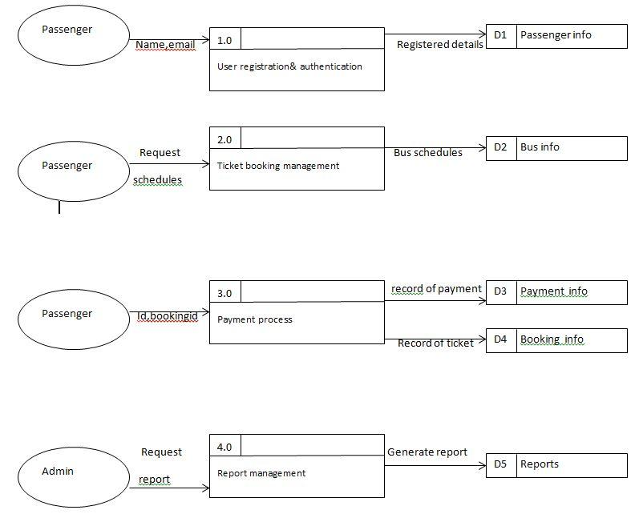

4.7 Context Diagram
A Context Diagram provides a high-level overview of the E-Ticket, showing:
- The system’s interaction with external entities (Passengers and Admins).
- The overall process as a single entity, representing how it fits into the larger business workflow.
- The flow of data between the system and external users, without detailing internal processes.
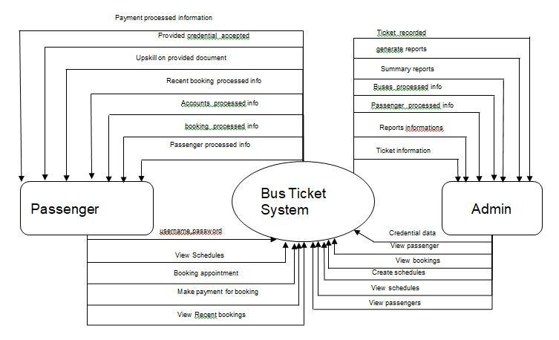
Figure 3:Context Diagram

4.8 DFD Level 1 for E-Ticket
A Level 1 Data Flow Diagram (DFD) for the E-Ticket Represents the major sub-processes of the system and their interactions with external entities and data stores. It decomposes the overall ticketing system into core components, providing a clear view of how data flows between different parts of the system.
The Level 1 DFD for the E-Ticket Breaks down the ticketing process into distinct components:
- User Registration, Ticket Booking, Payment Processing, and Report Generation.
- It ensures that all user-specific tasks (e.g., booking for passengers, scheduling for admins, and payment processing) are streamlined and interconnected.
- The system's design emphasizes the efficient storage, retrieval, and processing of data to meet the needs of its users.
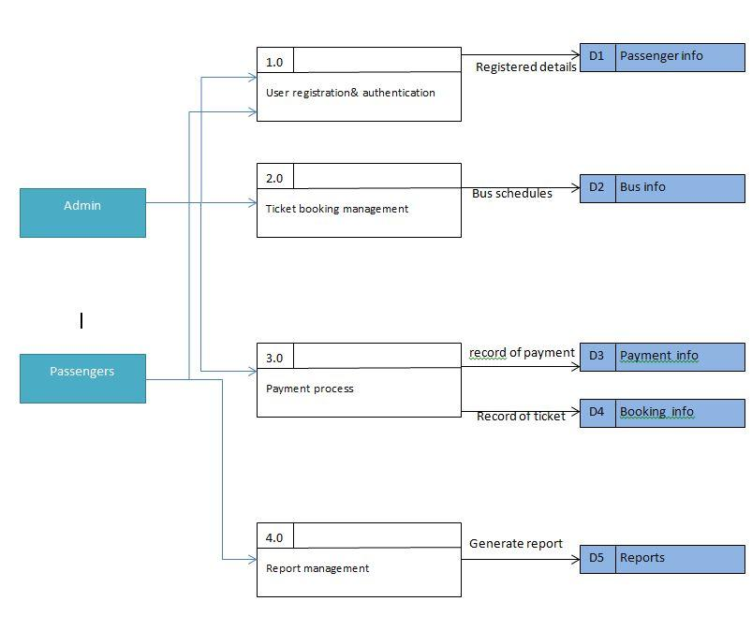
Figure 4: DFD Level 1.

4.9 DFD Level 2 for E-Ticket

1. User Registration and Authentication (Level 2)
This major process is responsible for registering passengers and authenticating their details. The Level 2 breakdown includes:
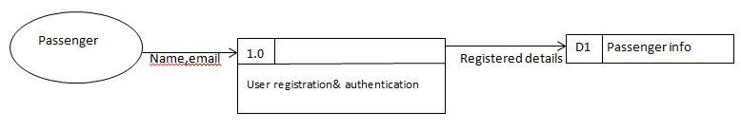
Figure 5: Sub-Processes of User Registration and Authentication

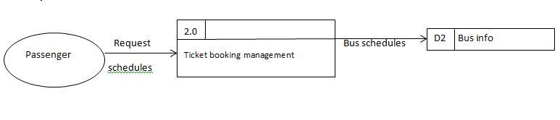
Figure 6:Sub-Processes of Ticket Booking Management

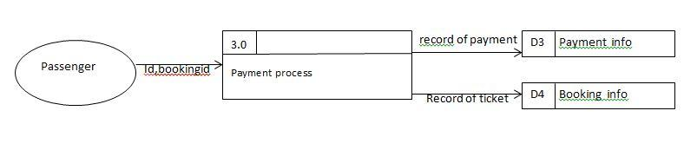
Figure 7: Sub-Processes of Payment Processing
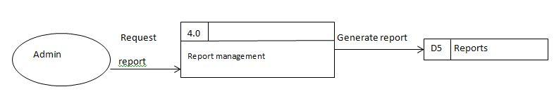
Figure 8:Sub-Processes of Report Processing

4.10 Entity Relationship Diagram (ERD)
An Entity Relationship Diagram (ERD) is a data modelling technique that creates a graphical representation of the entities and their relationships within the E-Ticket. It uses symbols to represent three different types of information:
- Boxes are used to represent entities.
- Diamonds are used to represent relationships.
- Ovals are used to represent attributes.
The ERD typically consists of four graphical components:

Entity
An entity represents a piece of data—an object or concept that is stored. It is a person, object, place, or event for which data is collected. In the E-Ticket, examples of entities could include:
- Passenger (Represents the customer who books the bus ticket)
- Bus (Represents the bus with a specific route, schedule, and capacity)
- Ticket (Represents the actual bus ticket that is issued to the passenger)
- Payment (Represents the payment transaction for the ticket)
- Schedule (Represents the bus timetable and route details)
- Report (Represents reports generated for sales, user activity, and transactions)
Each entity is represented by a rectangle and labelled with a singular noun.

Relationship
A relationship represents how data is shared between entities. Relationships may be represented by a diamond shape or a line connecting entities, with verbs used to label the relationship.
In the E-Ticket, the possible relationships between entities are as follows:
- Passenger books Ticket (A passenger can book many tickets, but each ticket is associated with only one passenger).
- Ticket is issued for Bus (Each ticket is issued for one bus, but each bus can have many tickets associated with it).
- Passenger makes payment for Ticket (Each passenger makes a payment for each ticket).
- Bus is part of Schedule (Each bus is linked to a specific schedule, but each schedule can have multiple buses).

Types of Relationships:
- One-to-one(1,1)
One instance of an entity (A) is associated with one other instance of another entity (B).
For example: Each Bus may have a unique Schedule for a given time slot.
- One-to-many(1,N):
One instance of an entity (A) is associated with zero, one, or many instances of another entity (B), but for one instance of entity B, there is only one instance of entity A.
For example: One Passenger can book multiple Tickets, but each Ticket can only be booked by one Passenger.
- Many-to-many (N, N):
One instance of an entity (A) is associated with one, zero, or many instances of another entity (B), and one instance of entity B is associated with one, zero, or many instances of entity A.
For example: A Passenger can book many Tickets for different Buses, and each Bus can have many Passengers.

Cardinality
In data modelling, the cardinality defines the relationship between data tables in terms of numbers. It explains how each table links to another. For example:
- Passenger to Ticket: One Passenger can have many Tickets, but each Ticket is booked by only one Passenger.
- Ticket to Bus: Each Ticket is associated with one Bus, but one Bus can have many Tickets.

Attribute
An attribute is a characteristic common to all or most instances of a particular entity. Attributes represent data elements that help describe or define the entity. In the E-Ticket, attributes might include:
- Passenger: Name, Email, Phone Number, ID Number
- Bus: Bus Number, Capacity, Route, Type
- Ticket: Ticket Number, Booking Date, Seat Number, Price
- Payment: Payment Method, Amount, Payment Date, Transaction ID
- Schedule: Route, Departure Time, Arrival Time
- Report: Report ID, Date Generated, Sales Data
Each attribute is represented by an oval shape and is connected to its respective entity.
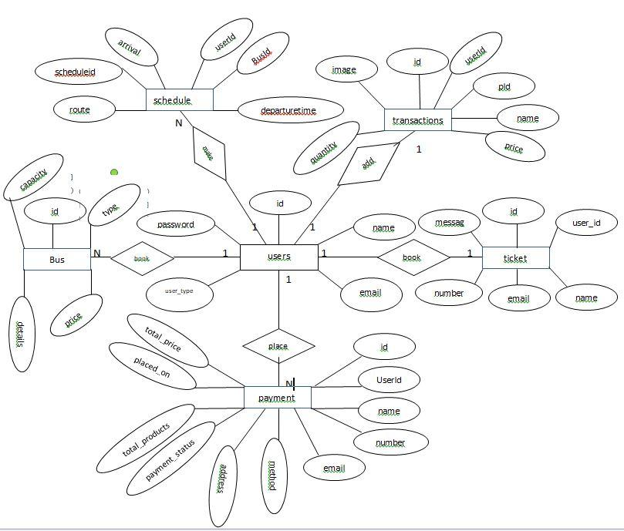
Figure 9:ERD for E-Ticket

4.11 Logical Data Model (LMD)
The Logical Data Model (LDM) describes the data in detail, without considering how it will be physically implemented in the database. This stage involves defining all the entities, their attributes, primary keys, relationships between entities, and resolving any many-to-many relationships.

Steps for Designing the Logical Model of Data:
- Identify all entities
- Specify primary keys for all entities
- Find the relationships between different entities
- Resolve many-to-many relationships
- Find all attributes for each entity
This Logical Data Model (LMD) outlines the structure of the E-Ticket, defining the key entities (Bus, Passenger, Ticket, Transaction, Payment, and Schedule), their relationships, primary keys, and attributes. The relationships between the entities are clearly defined to ensure the system can handle bookings, payments, schedules, and transactions effectively. The LMD represents a high-level structure designed to manage bus tickets, passengers, payments, and schedules

4.12 Data Dictionary for E-Ticket
A Data Dictionary is a collection of descriptions of data objects or items within a data model, providing clear and concise definitions for programmers and stakeholders who interact with the system. The process of data modelling involves identifying each object, its relationships with other objects, and its attributes. By providing a comprehensive data dictionary, all the system's data objects can be understood in real-world terms, and programmers can refer to it to understand data structures and relationships.
Here is a Data Dictionary for the E-Ticket:

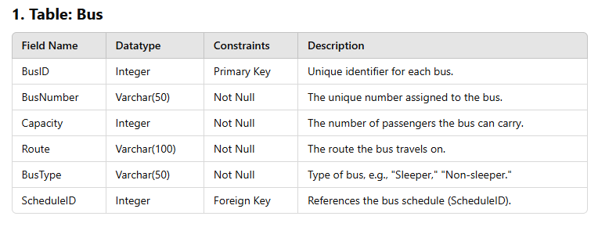
Table 1:bus table

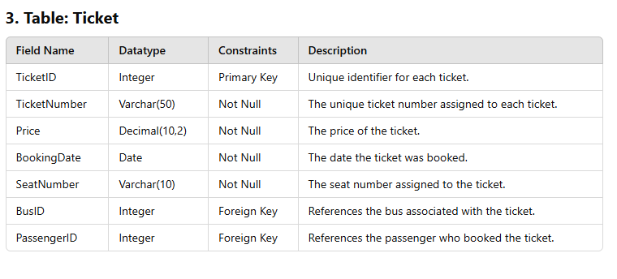
Table 2: Ticket table
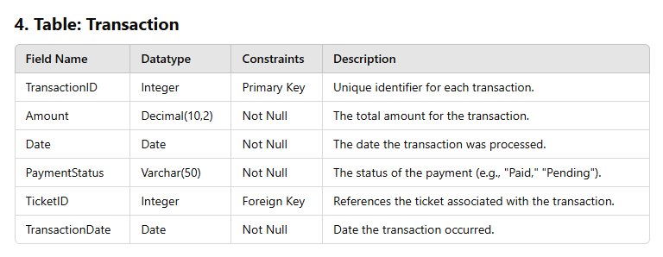
Table 3: transaction table

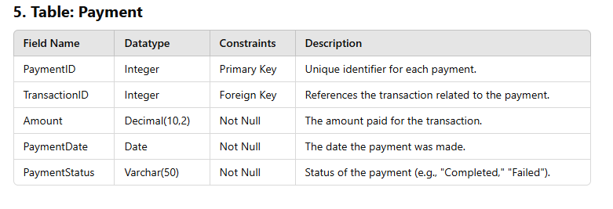
Table 4: Payment table

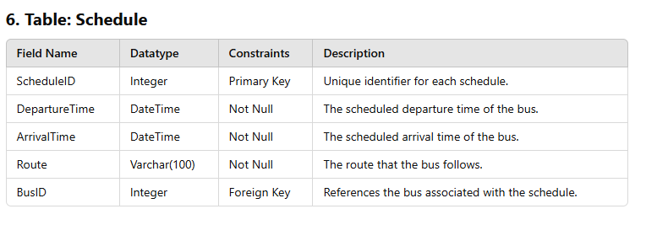
Table 5: schedule table

4.13 Physical Data Model (PDM)
A Physical Data Model (PDM) represents how data is physically stored in a database, including tables, columns, data types, constraints, relationships, and indexes. It is the most detailed level of data modelling and directly influences database implementation. The E-Ticket requires a well-structured database to manage users, bus routes, ticket purchases, and transactions efficiently. The following sections outline the database tables, their attributes, and relationships, using Primary Keys (PK) and Foreign Keys (FK) to establish connections between them.
At this level, we describe the actual structure of the database, specifying the tables, columns, and relationships (foreign keys) that will physically store the data.
1. Convert Entities into Tables
Each entity from the Logical Data Model is converted into a table. The columns for each table are derived from the attributes of the corresponding entity.

2. Convert Attributes into Columns
Each attribute becomes a column in its respective table, with data types specified according to the expected type of data (e.g., text, integer, and float).

3. Define relationship with Foreign Keys
Foreign keys are defined to establish the relationships between the tables.

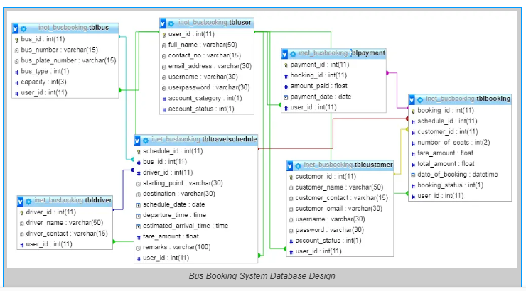
Figure 10: Physical data model

CHAPTER FIVE: IMPLEMENTATION OF THE NEW SYSTEM

5.1. Introduction
System implementation is the process of putting a designed system into operation. It involves acquiring, developing, and installing necessary hardware and software, testing the system, creating documentation, and training users to operate and utilize the system effectively. The organization then transitions to using the newly developed system.
Implementing the E-Ticket began with creating the database as outlined in its data dictionary design. All relationships between entities were applied to ensure data integrity and efficient storage. After the database setup, the next step was designing and coding various forms required for data input, management, and retrieval. These forms serve as the primary interface for interacting with the database. The following step was creating different reports using PHP/Laravel, HTML, and JavaScript to meet user requirements. These reports are generated from queries and present critical information to stakeholders in an easy-to-understand format.

5.2. System Interface
The interface design for the E-Ticket focuses on creating an intuitive and user-friendly experience for all users, including passengers and administrators. The design emphasizes simplicity, functionality, and efficiency, ensuring seamless interaction between the users and the system.
Key aspects of the interface include:
- Visual Layout: Clear and organized layouts with appropriate color schemes and typography to enhance usability.
- Navigation: Easy-to-use menus and buttons to facilitate smooth movement between system functionalities.
- Forms: Input forms designed for adding, updating, and deleting records in the database, with appropriate validation to minimize errors.
- Reports: Dynamic reports generated based on user queries to provide actionable insights and decision-making support.
The project was developed and tested using modern web browsers, with Google Chrome being the primary testing environment. Below are screenshots that demonstrate the system's interface and functionality.

5.3 Screenshots
Initial Login Page
The login page is the entry point to the system, requiring users to log in with their credentials to ensure security and restrict access to authorized users only.
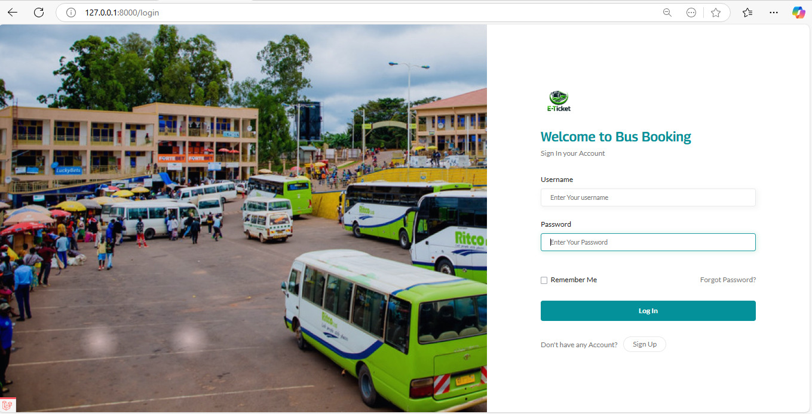
Figure 15: Login Page
Admin Dashboard
The dashboard provides an overview of key metrics, including the total number of passengers, available buses, upcoming trips, booked tickets, and completed transactions. It serves as the central hub for navigation.
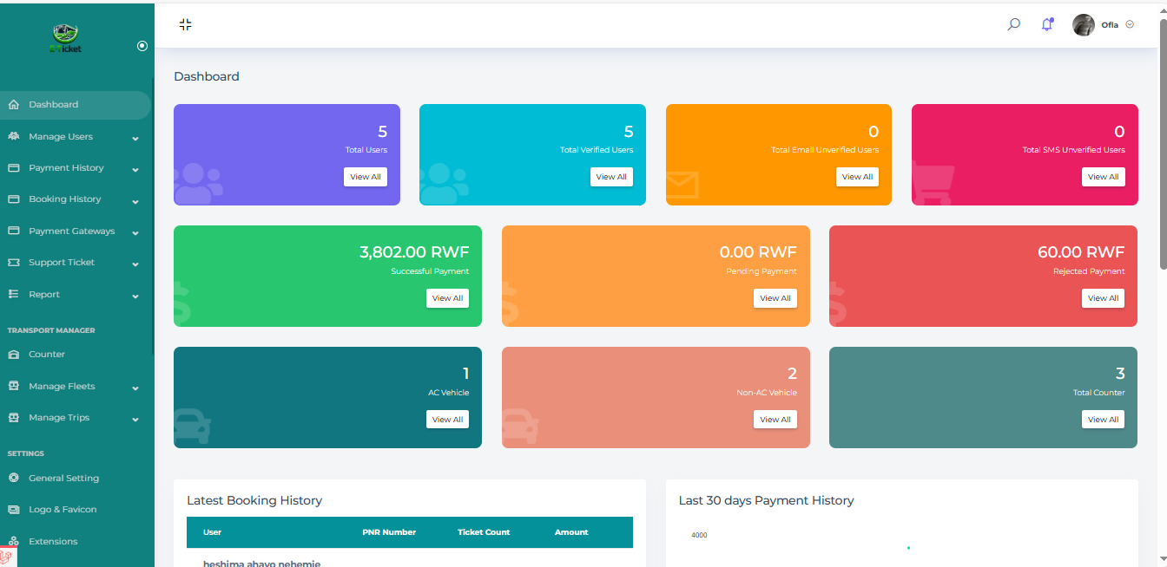
Figure 16: Admin Dashboard

Bus Schedule Management Page
This page allows administrators to add, edit, or remove bus schedules. Details such as departure time, arrival time, and assigned bus are managed here.
Figure 17: Bus Schedule Management Page

Passenger Booking Page
Passengers can book tickets by selecting a route, schedule, and seat. Ticket prices and seat availability are displayed.
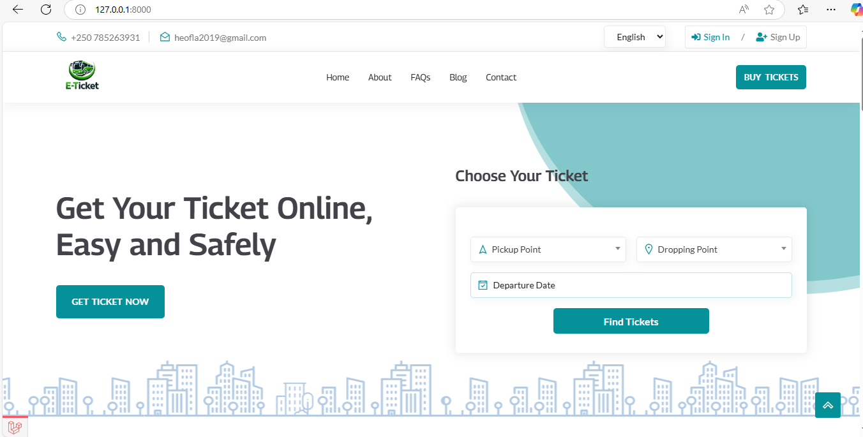
Figure 18: Passenger Booking Page
Payment Confirmation Page
After booking, passengers proceed to payment. This page allows users to confirm payment details, choose a payment method, and complete the transaction securely.
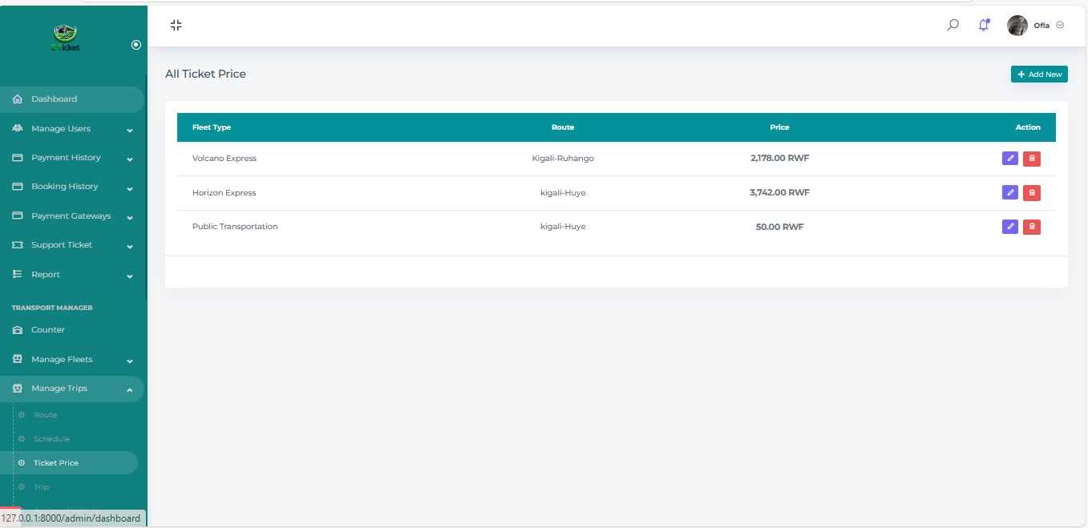
Figure 19: Payment Confirmation Page
Transaction History Page
Users can view their past transactions, including details of booked tickets, payment status, and travel history.
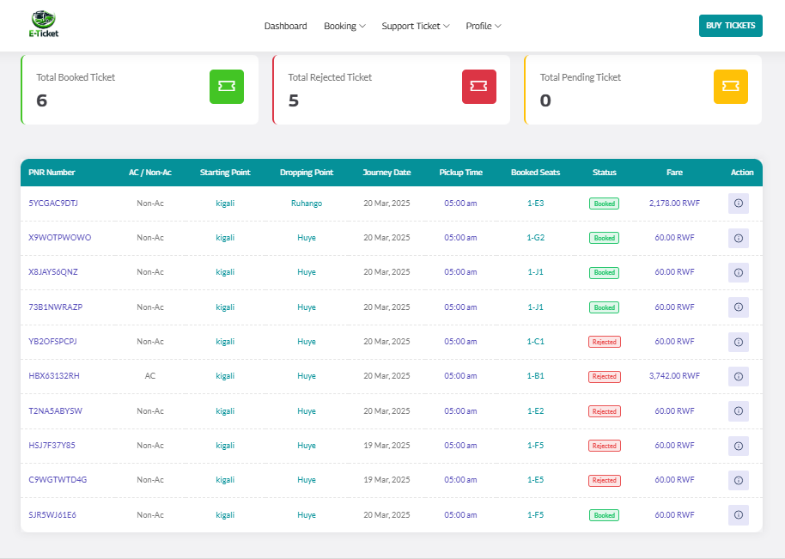
Figure 20: Transaction History Page
Report Generation Page
This page enables users to generate reports related to ticket sales, bus occupancy, and revenue trends.
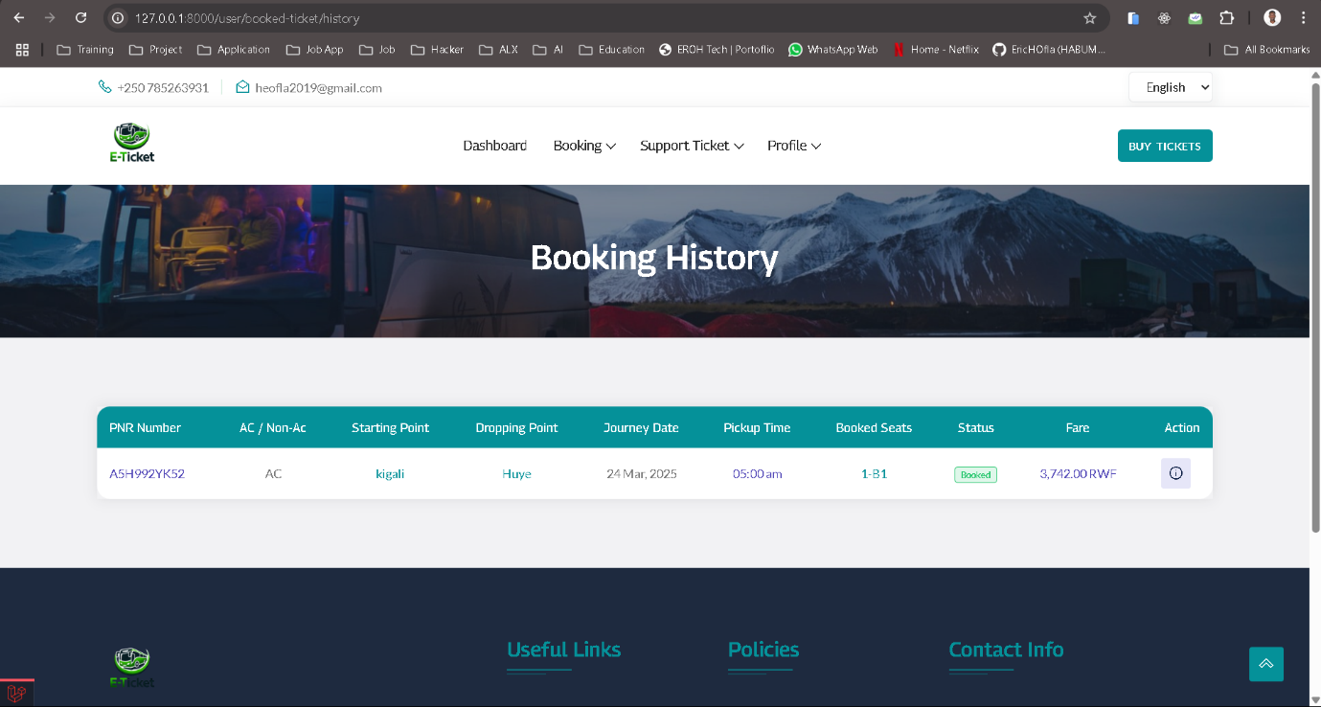
Figure 21: Report Generation Dashboard
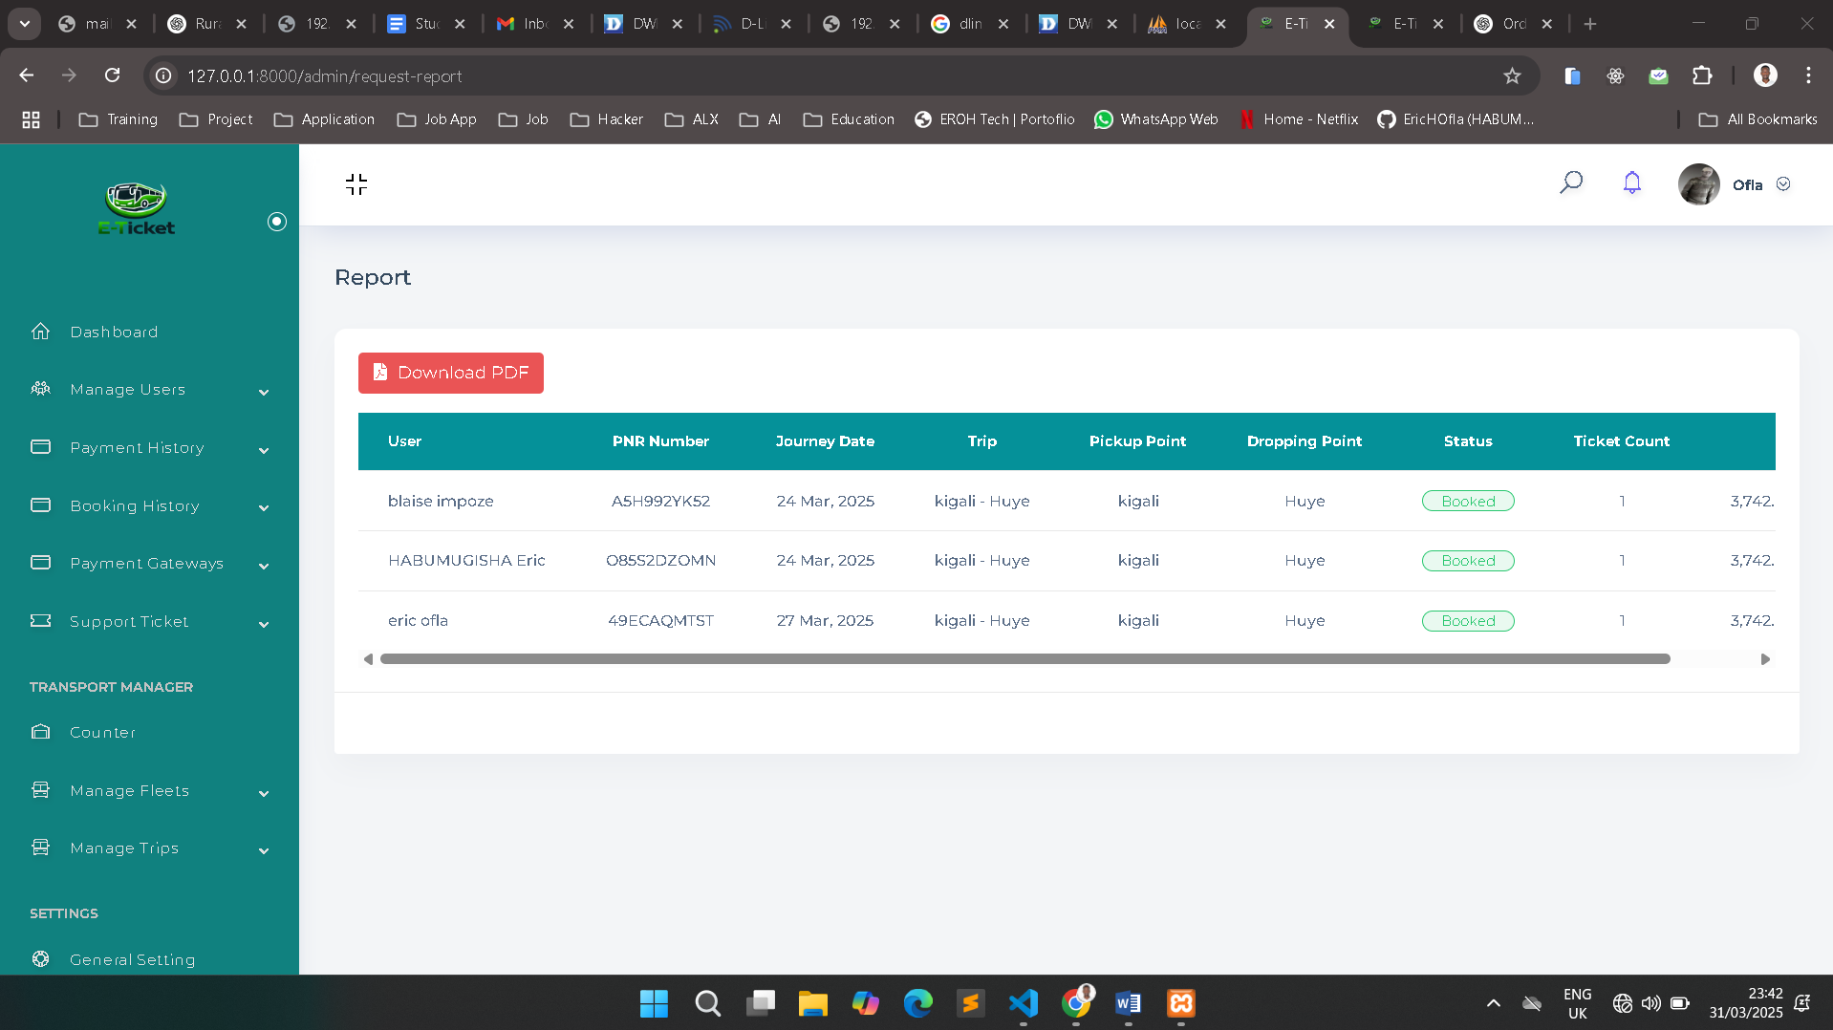
Figure 22: General Report
The implementation of the E-Ticket ensures efficiency, ease of use, and data accuracy, providing a seamless experience for both administrators and passengers.

CHAPTER SIX: CONCLUSION AND RECOMMENDATION

6.1. Introduction
The E-Ticket was developed to streamline the ticket booking and management process for passengers and administrators. The traditional methods of booking tickets manually were inefficient, prone to errors, and time-consuming. The system enables users to book tickets, manage schedules, process payments, and generate reports efficiently. With the integration of real-time data and automation, decision-making and service quality have significantly improved. The functional and non-functional requirements identified during the analysis phase were successfully implemented, along with additional features to enhance usability and functionality.

6.2. Problem Encountered
Several challenges were faced during the development and implementation of the E-Ticket:
• Technical Challenges: Learning new programming techniques, frameworks, and database management tools required extensive research and debugging.
• Integration Issues: Implementing features such as payment gateways and real-time schedule updates required overcoming compatibility issues between different system components.
• User-Centric Design: Understanding and translating user requirements into technical specifications was challenging, especially for non-technical users who provided feedback in general terms.
• Time Management: Balancing development tasks, testing, and debugging while adhering to project deadlines required efficient time allocation and prioritization.

6.3. Lessons Learnt
The development of the E-Ticket Provided valuable insights and experience:
• Requirement Gathering: Improved skills in collecting and analysing user needs to create a system that is both functional and user-friendly.
• Technical Proficiency: Gained hands-on experience with PHP Laravel, MySQL, and front-end technologies like HTML, CSS, and JavaScript.
• Problem Solving: Enhanced ability to troubleshoot and resolve system integration, UI design, and data management issues.
• Project Management: Learned to manage project timelines effectively, balancing development, testing, and user feedback.

6.4. Critical Assessment of the Project
Based on system evaluations and user feedback, the E-Ticket Has successfully met its initial objectives. The system's functional requirements, as outlined in the system analysis phase (CHAPTER 03: EXISTING SYSTEM ANALYSIS), are summarized below:
Manage Bus Schedules: Allows administrators to create and manage bus routes, departure times, and seating arrangements.
Manage Ticket Bookings: Enables passengers to book, modify, or cancel tickets based on seat availability.
Manage Passenger Information: Stores and manages passenger details to facilitate a smooth booking process and record-keeping.
Manage Payments: Handles online and mobile money payments to provide secure transactions.

6.5 Generate Reports:
Provides custom reports for monitoring ticket sales, route popularity, and system performance.
The non-functional requirements of the system are summarized below:
User Friendliness: Provides an intuitive and accessible interface for all users.
System Reliability: Ensures accurate and secure data storage and retrieval.
Simple Interfaces: Delivers clean and efficient interfaces for easy navigation.
All the above functional and non-functional requirements have been successfully met. Additionally, new features and future enhancements were identified during system development.

6.6 Recommendation
The E-Ticket was developed with scalability and maintainability in mind, ensuring ease of upgrades and enhancements. To further improve the system, the following future enhancements are recommended:
Implementing Real-Time bus tracking: Allow passengers to check the location of the bus and know where the bus is exactly for them to know how much time they are going to spend waiting for the bus.
Expanding Payment Methods: Enable seamless mobile payment integration via MOMO and Airtel Money, ensuring that passengers without smartphones receive transaction confirmation.
Improving Customer Notifications: Enhance the notification system to send reminders and alerts about upcoming trips, delays, and promotions through email, SMS, and push notifications.
By implementing these recommendations, the E-Ticket can provide an even more seamless experience for users and stakeholders, increasing efficiency and customer satisfaction

2.8 References
- Elmasri, R., & Navathe, S. B. (2015). Fundamentals of Database Systems (7th ed.). Pearson.

- Korth, H. F., & Silberschatz, A. (2019). Database System Concepts (7th ed.). McGraw-Hill Education.

- Singh, S. K. (2011). Database Systems: Concepts, Design and Applications. Pearson Education India.
- Hafezi, M. H., & Ismail, A. (2012). “Comparative Analysis of Fare Collection System on Bus Operations.” Journal of Applied Sciences, 12(4), 393-397.
scialert.net
- Pandimurugan, V., Jayaprakash, R., Rajashekar, V., & Yogeshwar Singh, K. (2022). “Smart Bus Pass System.” International Journal of Advanced Research in Computer and Communication Engineering, 9(3), 70-75.
researchgate.net
- Hafezi, M. H., & Ismail, A. (2011). “A Comparative Analysis for Two Methods of Fare Collection System.” In Proceedings of the International Conference on Traffic and Transportation Engineering (pp. 55-59). Dubai.

- CityMapper. (2025). CityMapper: The Ultimate Transport App. Retrieved March 4, 2025, from https://citymapper.com/

- Transit App. (2025). Transit: Real-Time Transit App. Retrieved March 4, 2025, from https://transitapp.com/
- Hafezi, M. H., & Ismail, A. (2011). “A Comparative Analysis for Two Methods of Fare Collection System.” In Proceedings of the International Conference on Traffic and Transportation Engineering (pp. 55-59). Dubai.
- CityMapper. (2025). CityMapper: The Ultimate Transport App. Retrieved March 4, 2025, from https://citymapper.com/
- Transit App. (2025). Transit: Real-Time Transit App. Retrieved March 4, 2025, from https://transitapp.com/

